**IM3080 Design and Innovation Project (AY2021/ Semester 1)**

**Individual Report**

Name: Linn Boon Jie

Group No: 2

Project Title: Float

**Contributions to the Project** (1-2 page)

**Avatar Design and Avatar Related Assets**- Designed and drawn the mascot from scratch, starting from the rough concept sketches to its final design form.   
- Designed and drawn all the mascot shop assets in the Rewards Shop (Hats, Accessories, Backgrounds)  
- Designed and drawn the App’s Logo and animated Splash Screen

**App Wireframe Design on Figma**- Designed and planned the Layouts and Wireframes for the Profile, Login and Rewards pages  
- Designed some miscellaneous icons  
  
**Promotional Poster** - Designed the extra Promotional Poster to be used for presentation and submission   
  
**Presenter / Slide Designer for All Major Graded Presentations**- Lead presenter for App Introduction and Design related updates   
- Lead presenter for Final Week 14 Presentation  
  
**Group Report**- Proof reading of the Report, along with adding content into it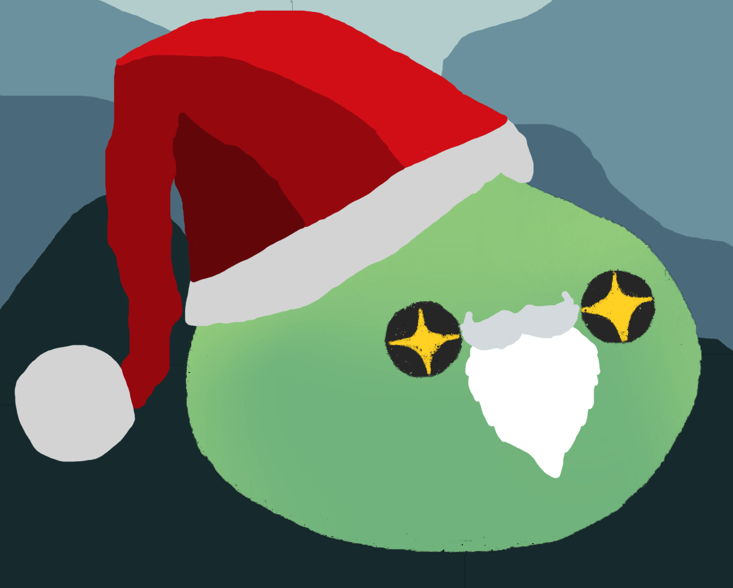****

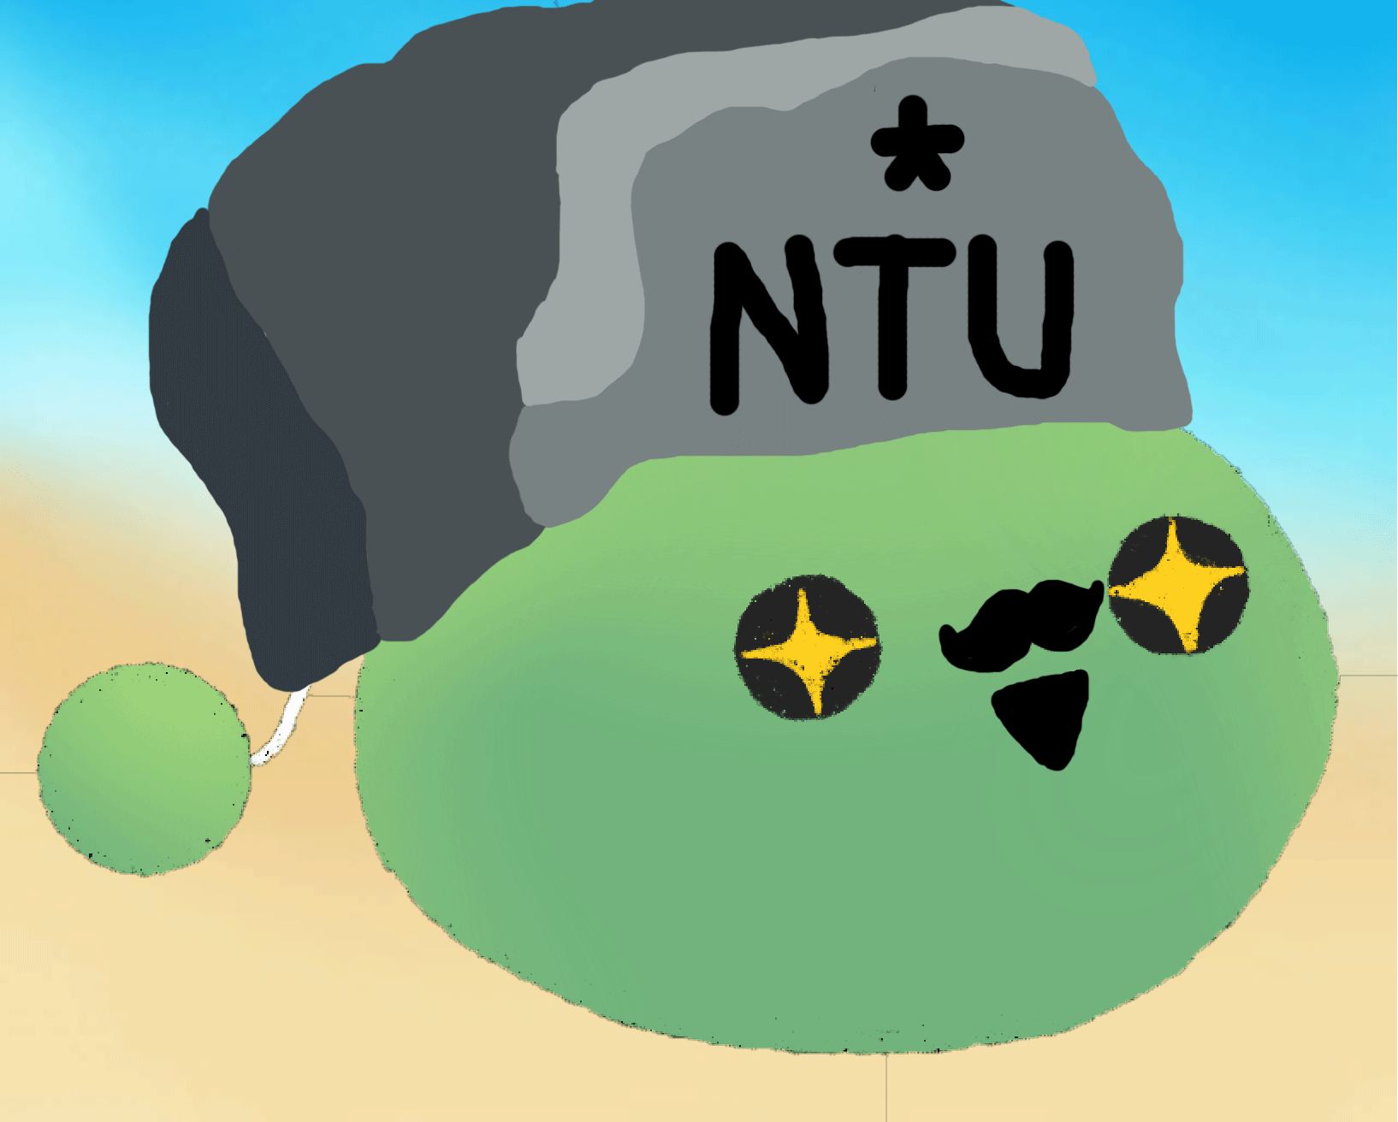

**Reflection on Learning Outcome Attainment**

**Reflect on your experience during your project and the achievements you have relating to at least two of the points below:**

1. Engineering knowledge
2. Problem Analysis
3. Investigation
4. Design/development of Solutions
5. Modern Tool Usage
6. The Engineer and Society
7. Environment and Sustainability
8. Ethics
9. Individual and Team Work
10. Communication
11. Project Management and Finance
12. Lifelong Learning

Point 1: Modern Tool Usage | State the area: Photoshop / Figma / GitHub

Learnt, improved and gained new skills in Photoshop, GitHub and Figma. Did not previously knew of any collaborative team tools for designing wireframes and mockups. This helped to broaden my perspective and openness to using other software for collaborative work. Regarding Photoshop, through this project, I have gained more knowledge and skills with editing and designing via individual self-research. Tackled on previously unknown areas such as animations and designing visuals from the ground up. Also familiarized myself with learning how GitHub works, will use it for my future group projects for documents and codes when needed.

Point 2: Individual and Team Work | State the area: Volunteering for Tasks and Open Mindedness  
  
There is a lack of willingness when it comes to doing certain tasks such as those that involve presentations, hence I actively step forward to take on the road to get things rolling. When it came to team work, be it rehearsals for presentation or for the design work, problems do sometime come up when different opinions and feedback arise. I kept an open and receptive mind to consider and balance out the benefits and drawbacks of the different suggestions available.

Point 3: Communication | State the area: Being Mindful and Respectful  
  
This is my first time working in such a large group size with a total of 11 members. With many different opinions, ideas and voices about, communicating clearly was an issue at the start where we would talk over each other, more so for me as I had the tendency to interrupt others while they were talking. I’ve learnt to be more patient when it comes to adding in additional input; only speaking forth when the rest have finished saying their piece.